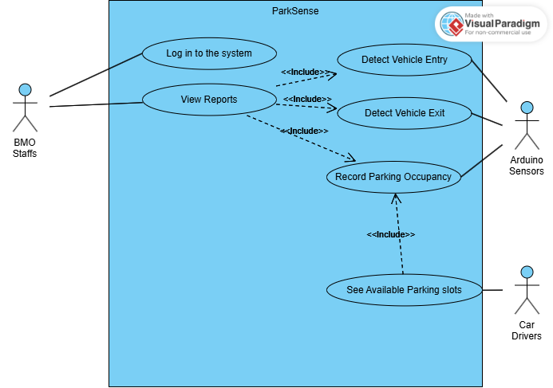

Fully Dressed Use Case: Login in to the system

|  |  |
| --- | --- |
| Use Case ID | PAS_UC_1 |
| Use Case Name | Login in to the system |
| Created By | John Jorel Landicho |
| Date Created | 9/16/2024 |
| Description | This use case describes the process of logging into the ParkSense system, allowing authorized users (BMO Staff) to access specific system functions after successful authentication. |
| Primary Actor | BMO Staff |
| Preconditions | 1. The Park Sense system is operational. 2. The user has a valid username and password. |
| Postconditions | Success: The user is logged into the system and can perform their assigned tasks.    Failure: The system denies access, and no tasks can be performed until a successful login. |
| Main Success Scenario (Basic Flow) | 1. The actor (BMO Staff) opens the ParkSense system login screen. 2. The system displays fields for the username and password. 3. The actor inputs their username and password. 4. The system checks the entered credentials against its database. 5. The system confirms that the credentials are correct and logs the actor into the system. 6. The actor is redirected to the appropriate dashboard based on their role (e.g., BMO Staff is directed to the dashboard for analyzing data;). |
| Extensions (Alternate Flows) | 2a. Invalid Credentials:   * Trigger: The user enters an incorrect username or password. * Action: The system detects that the credentials do not match the database records. * Response: The system displays an error message ("Invalid username or password") and prompts the user to retry. |
| Special Requirements | 1. Passwords should follow security protocols (e.g., minimum length, complexity requirements). 2. The login interface should be simple and user-friendly. |

Fully Dressed Use Case: View Reports

|  |  |
| --- | --- |
| Use Case ID | PAS_UC_2 |
| Use Case Name | View Reports |
| Created By | ImPossible: John Jorel Landicho, Rchie Libudan, Angela Mae Tauyan, Timothy Jay Sayson |
| Date Created | 11/01/2024 |
| Description | This use case allows BMO Staff to view reports based on parking data collected by the system. |
| Primary Actor | BMO Staff |
| Include Use Case | 1. Detect Vehicle Entry 2. Detect Vehicle Exit 3. Record Parking Space Occupancy |
| Preconditions | 1. The Park Sense system is operational and has logged sufficient data. |
| Postconditions | Success: Accurate and comprehensive reports are generated.    Failure: Reports are missing key information or contain errors. |
| Main Success Scenario (Basic Flow) | 1. BMO Staff selects the "View Reports" option. 2. The system retrieves historical occupancy and usage data. 3. The system displays the data in a report format. |
| Extensions (Alternate Flows) | 2a. Report Contains Errors or Missing Data:   * Trigger: The system notifies the BMO Staff that there is no data available. * Action: The BMO Staff adjusts the report parameters or requests system maintenance. * Response: A corrected report is generated. |
| Special Requirements | 1. The reporting tool should support different formats (PDF, Excel). 2. Reports should include visual aids like charts and graphs for easy interpretation. |

Fully Dressed Use Case: Detect Vehicle Entry

|  |  |
| --- | --- |
| Use Case ID | PAS_UC_3 |
| Use Case Name | Detect Vehicle Entry |
| Created By | ImPossible: John Jorel Landicho, Rchie Libudan, Angela Mae Tauyan, Timothy Jay Sayson |
| Date Created | 11/01/2024 |
| Description | Detects when a vehicle enters the parking facility and updates occupancy data. |
| Primary Actor | Arduino Sensors |
| Preconditions | 1. Arduino sensors are functional and calibrated. |
| Postconditions | Success: The system records a new vehicle entry and updates parking occupancy.  Failure: The system fails to record new vehicle entry and not update the parking occupancy. |
| Main Success Scenario (Basic Flow) | 1. A vehicle passes through the entry point. 2. The Arduino sensor detects the vehicle's entry. 3. The system increments the count of occupied parking slots. |
| Extensions (Alternate Flows) | 2a. If the sensor fails to detect a vehicle entering:   * Trigger: The system prompts BMO Staff to check the entry status. * Action: The BMO Staff check the actual device and do some maintenance. * Response: Updates the occupied parking slots. |
| Special Requirements | 1. The system must update occupancy within 2 seconds of detection. |

Fully Dressed Use Case: Detect Vehicle Exit

|  |  |
| --- | --- |
| Use Case ID | PAS_UC_4 |
| Use Case Name | Detect Vehicle Exit |
| Created By | ImPossible: John Jorel Landicho, Rchie Libudan, Angela Mae Tauyan, Timothy Jay Sayson |
| Date Created | 11/01/2024 |
| Description | Detects when a vehicle exits the parking facility and updates occupancy data. |
| Primary Actor | Arduino Sensors |
| Preconditions | 1. Arduino sensors are functional and calibrated. |
| Postconditions | Success: The system records the vehicle exit and updates parking occupancy.  Failure: The system fails to record vehicle exit and not update the parking occupancy. |
| Main Success Scenario (Basic Flow) | 1. A vehicle passes through the exit point. 2. The Arduino sensor detects the vehicle's exit. 3. The system decrements the count of occupied parking slots. |
| Extensions (Alternate Flows) | 2a. If the sensor fails to detect a vehicle exiting:   * Trigger: The system prompts BMO Staff to check the exit status. * Action: The BMO Staff check the actual device and do some maintenance. * Response: Updates the occupied parking slots. |
| Special Requirements | 1. The system should reflect the updated count within 2 seconds. |

Fully Dressed Use Case: Record Parking Occupancy

|  |  |
| --- | --- |
| Use Case ID | PAS_UC_5 |
| Use Case Name | Record Parking Occupancy |
| Created By | ImPossible: John Jorel Landicho, Rchie Libudan, Angela Mae Tauyan, Timothy Jay Sayson |
| Date Created | 11/01/2024 |
| Description | Records current parking occupancy based on vehicle entries and exits. |
| Primary Actor | Arduino Sensors |
| Preconditions | 1. ParkSense system is active and logging entry/exit data. |
| Postconditions | Success: The parking occupancy is accurately recorded and available for reporting.  Failure: The system fails to accurately record the parking occupancy. |
| Main Success Scenario (Basic Flow) | 1. The system tracks each vehicle entry and exit. 2. The occupancy data is updated in real-time. 3. The system logs the occupancy status for historical reporting. |
| Extensions (Alternate Flows) | 1a. If there is an inconsistency in the entry/exit count:   * Trigger: The system alerts BMO Staff for manual verification. * Action: BMO Staff logs into the system and reviews the data. * Response: BMO Staff performs a manual override to correct the occupancy count if necessary. |
| Special Requirements | 1. Data must be stored in a secure database accessible only by authorized personnel. |

Fully Dressed Use Case: Record Parking Occupancy

|  |  |
| --- | --- |
| Use Case ID | PAS_UC_6 |
| Use Case Name | Record Parking Occupancy |
| Created By | ImPossible: John Jorel Landicho, Rchie Libudan, Angela Mae Tauyan, Timothy Jay Sayson |
| Date Created | 11/01/2024 |
| Description | Allows Car Drivers to view available parking slots displayed at the entrance. |
| Primary Actor | Car Drivers |
| Include Use Case | 1. Record Parking Occupancy |
| Preconditions | 1. ParkSense system is operational and updated in real-time. |
| Postconditions | Success: Car Drivers are informed of the number of available slots.  Failure: The system fails to accurately record the parking occupancy, leading to inconsistent slot availability information for Car Drivers |
| Main Success Scenario (Basic Flow) | 1. The system calculates the available parking slots based on occupancy data. 2. The system updates the display board with the current count of available slots. |
| Extensions (Alternate Flows) | 1a. If the display board is malfunctioning:   * Trigger: The system detects an issue with the display board. * Action: The BMO Staff performs diagnostic checks or repairs to restore functionality. * Response: Display board is working and updated. |
| Special Requirements | 1. Display visibility must meet local safety standards and be readable from at least 10 meters away. |